**Project Report**

**Hospital management system**

**(C++)**

***Submitted in partial fulfillment of degree of***

**BCA (2017-2020)**

## Unde the guidance of MR SAFDAR TANWEER Faculty, JAMIA HAMDARD

## Submitted by:

**SHREYANSH SHEKHAR**

**Enrolment No.** **ODL/17/401/20154**

***BCA***



**Student’s declaration**

I hereby declare that the project entitled **“HOSPITAL MANAGEMENT”** under the guidance of **“”****MR SAFDAR TANWEER “**submitted to

JAMIA HAMDARD **BCA** .This is my original work and this project work has not formed the basis for the award of Degree to the best of my belief and knowledge.

**SHREYANSH SHEKHAR**

**ODL/17/401/20154**

[SIGNATURE OF STUDENT]

Place: New Delhi Date: 2020



**Certificate**

This is to certify that the project entitled **“HOSPITAL MANAGEMENT”** In programming Langauge **C++** is an original work of **“SHREYANSH SHEKHAR ”** of BCA , FINAL YEAR and has been duly completed under my guidance and supervision.

.

## Signature of the Guide

**MR SAFDAR TANWEER**

**Acknowledgement**

It is my pleasure to acknowledge many people who knowingly and unwittingly helped me, to complete my project. First of all, let me praise God for all the blessings, which carried me through all those years.

I am particularly indebted to Director , jamia Hamdard which inculcated in me utmost respect for human values and groomed me up in the field of software technology to take on the challenges of the competitive world.

First & foremost, I would like to express my regards to **MR SAFDAR TANWEER** for her constant encouragement and support. I would also like to express my immense gratitude towards all the lectures of our college for providing the invaluable knowledge, guidance, encouragement extended during the completion of this project.

I extended my sincere gratitude to all my teachers and guide which made unforgettable contribution. Due to their sincere efforts I was able to excel in the work entrusted upon me.

**Date : 8 june** /**2020**

**Name : Shreyansh Shekhar**

**Enrollment N0. :ODL/17/401/2015**

**Course: 3 rd year BCA**

(SIGNATURE OF STUDENT)

**HOSPITAL**

A hospital is a health care institution providing patient treatment with specialized staff and equipment. Hospitals are usually funded by public sector by health organisations (for profit or non-profit), by health insurance companies, or by charities, including direct charitable donations. Hospitals have a range of departments (e.g., surgery, and urgent care etc). HOSPITAL MANAGEMENT SYSTEM A hospital management system is an information system that manages the aspects of a hospital. This may include the administrative, financial, and medical processing. It is an integrated end-to-end Hospital Management System that provides relevant information across the hospital to support effective decision making for patient care, hospital administration and critical financial accounting, in a seamless flow. This program can look after Inpatients, OPD patients, records, database treatments, status illness, billings etc. it also maintains their hospital info such as ward id, Doctor in Charge, Department administering etc. Now with a laboratory module to handle all lab operations...!!! Not only has this it also looked after doctor and staff records and payments. Now with advanced features like LAN connectivity, ICD10 disease database, Webcam support Once in the role of management, there are a lot of responsibilities that need to be handled by the individual in this role. Hospitals are multifaceted systems, where there are hundreds of operations going on at one time.

The business side of the healthcare is vital to the lifeline of the system, especially in hospitals. Hospital managers need to have top-notch business sense to run the hospital efficiently, and they focus much of their time and attention on issues such as budgeting, hospital public relations and marketing, and billing and collections from insurance companies or other payers affiliated with their network.

However, the concerns of hospital managers go beyond business and directly into the delivery of care. Managers must maintain their ethical responsibilities while ensuring that all operations throughout the hospital are running smoothly, from surgery schedules, patient flow, record updates and confidentiality, waste management, and equipment maintenance and set up, to name a few.

There is no doubt that hospital managers have their hands full when it comes to their day-to-day operations, but they play a crucial role in ensuring patient care and in the success of the hospital as a whole.

**NEED OF HMS**

1. Minimized documentation and no duplication of records.

2. Reduced paper work.

3. Improved Patient Care

4. Better Administration Control

5. Faster information flow between various departments

6. Smart Revenue Management

7. Effective billing of various services

8. Exact stock information

**Introduction**

The SRS is produced at the culmination of the analysis task. The function and performance allocated to software as part of the system engineering and refined by establishing a complete information description, a detailed functional description, a representation of system behavior, indication of performance requirements and design constrains, appropriate validation criteria and the other information related to requirements. The SRS is technical specification of requirement of Hospital Management system. This specification describes what the proposed system should do without describing how it will do it. It also describes complete external behavior of proposed system.

**Purpose**

Hospital Management System is a process of implementing all the activities of the hospital in a computerized automated way to fasten the performance.

This project is to maintain the patient details, lab reports and to calculate the bill of the patient. You can also manually edit any patient details and issue bill receipt to patient within few seconds.

The main purpose of our system is to make hospital task easy and is to develop software that replaces the manual hospital system into automated hospital management system. This document serves as the unambiguous guide for the developers of this software system.

**Scope**

The document only covers the requirement specification for the hospital management system. This document does not provide any references to the other component of the hospital management system. All the external interfaces and the dependencies are also identified in this document.

•

**Feasibility Study**

The overall scope of the feasibility study was to provide sufficient information to allow a decision to be made as to whether the hospital management system project should proceed and so, its relative priority in the context of the other existing hospital management system. The feasibility study of this project had undergone through various steps which as describe as under:

a) Identify the origin of the information at different level.

b) Identify the expectation of user from computerized system.

c) Analyze the drawback of existing system.

**OVERALL DESCRIPTION**

**Product perspectives**

This project gives the procedural approach how a patient gets treatment, details about date of treatment and finally depending on different criteria like room allocated, lab reports, treatment and medicine taken.

**Product Function**

The data represented in hospital management application will perform the following major function:-

Patient Details: - It includes inpatient and outpatient details.

Tasks:- It includes the various tasks which are used in hospital .

**User Characteristics**

This software is developed such that total appearance of the product to make it more user friendly. The operator will be provided with login id and password. General users with basic computer skills can use this software.

**General Constraints**

Any update regarding the patient’s information from the hospital are to be recorded to have updated and correct value

**SPECIFIC REQUIREMENTS**

It describes all the details that the software developer need to know for designing and developing the system. This is typically the largest and most important part of the document.

**External Interface Requirements**

**User Interface**

User interface is designed in a user friendly manner and the user, in another end he has to give the order, for that he will interface with keyboard and mouse

**Language of coading:-**

using C+

**Communication Interface**

Windows

**Functional Requirements**

**Administration module**

This module enables the user to insert, update, view, search and delete the patient information.

**Patient module**

Data Members :- PatientId, Name, Age, Sex, BloodGroup, Marital Status ,Address, Phone Number.

**Task module**

This module is used by system admin to manage the system. It has following sub modules.

**.** Add New Patient :- This module is used to add a new patient.

**.**View Details :- This module is used to view the details of a previously admitted patient.

**.** Search :- This module searches the record of desired patient using his ID, Name, City or Blood Group.

**.** Eixt :- this module use eixt to the program.

**Updation module**

This module used to store or produce the patient reports .This updates patient info after each task. 3.3. Performance Requirements:-

The capability of the computer depends on the performance of thesoftware. The software can take any number of input provided the database size is large enough. This would depend on the available memory space.

**Design Constraints**

This will help the doctors or users to view the records of the patients immediately whenever necessary. They can also calculate the bill of the particular patients. This software also has the ability to add, update and delete the record whenever needed. This project will help to smoother the process of the hospital activites.

**SYSTEM FEATURES**

The users of the system should be provided the surety that their account is secure. This is possible by following:

User authentication and validation of members using their member ID.

Proper monitoring by the administrator which includes account status, showing a popup if wrong data is entered more than a required limit.

Privacy of personal details of patient maintained properly.

1.Add new patient record

2.add diagnosis information

3. Full history of patient

4.Information about hospital

5.Eixt the program

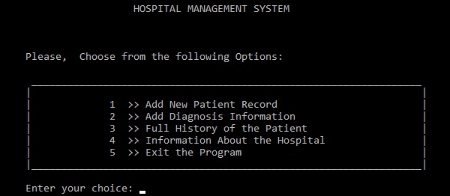

**E-R Diagram**

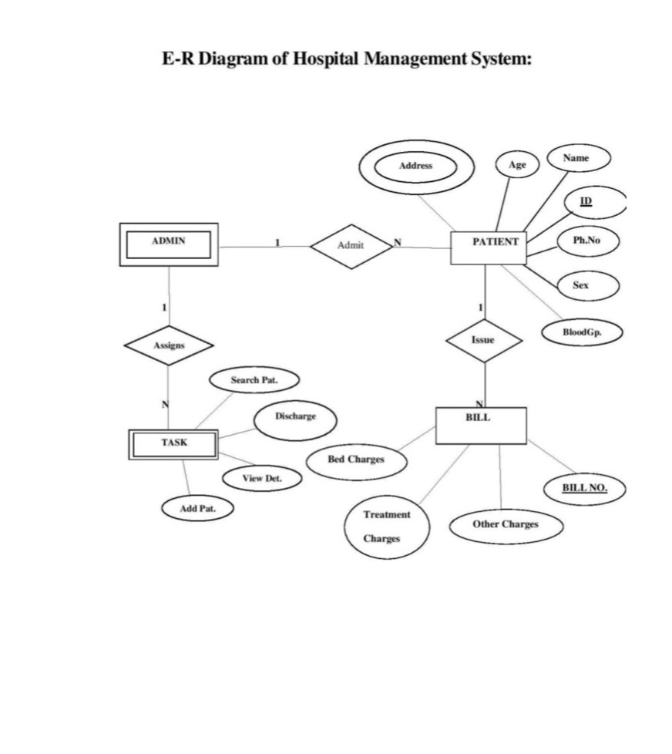

**COADING IN C++**

**//Hospital Management System .....**

#include<iostream>

#include<fstream>

#include<cstdlib>

#include<conio.h>

#include<time.h>

#include<iomanip>

using namespace std;

int main()

//NOTE: RUN THE PROGRAM IN FULL SCREEN ONLY

{

char fname[20];

time_t rawtime;

struct tm * timeinfo;

time ( &rawtime );

timeinfo = localtime ( &rawtime );

//printing the welcome note

re:

cout<<"\n\n\n\n\n\n\n\n\n\n\n\n\n\n\n\n\n\n\t\t\t\t\t@@@@@@@@@@@@@@@@@@@@@@@@@@@@@@@@@@@@@@@@@@@@@@@@@@@@@@@@@@@@@@@@@@@@@@@@@@@@@@@@@@@@@@@@@@@@@\n";

cout<<"\t\t\t\t\t@@ _______________________________________________________________________________________ @@\n";

cout<<"\t\t\t\t\t@@| |@@\n";

cout<<"\t\t\t\t\t@@| |@@\n";

cout<<"\t\t\t\t\t@@| |@@\n";

cout<<"\t\t\t\t\t@@| |@@\n";

cout<<"\t\t\t\t\t@@| |@@\n";

cout<<"\t\t\t\t\t@@| |@@\n";

cout<<"\t\t\t\t\t@@| *********** WELCOME TO ********** |@@\n";

cout<<"\t\t\t\t\t@@| |@@\n";

cout<<"\t\t\t\t\t@@| HOSPITAL MANAGEMENT SYSTEM |@@\n";

cout<<"\t\t\t\t\t@@| |@@\n";

cout<<"\t\t\t\t\t@@| |@@\n";

cout<<"\t\t\t\t\t@@| |@@\n";

cout<<"\t\t\t\t\t@@| |@@\n";

cout<<"\t\t\t\t\t@@| by:- |@@\n";

cout<<"\t\t\t\t\t@@| shreyansh shekhar |@@\n";

cout<<"\t\t\t\t\t@@|_______________________________________________________________________________________|@@\n";

cout<<"\t\t\t\t\t@@@@@@@@@@@@@@@@@@@@@@@@@@@@@@@@@@@@@@@@@@@@@@@@@@@@@@@@@@@@@@@@@@@@@@@@@@@@@@@@@@@@@@@@@@@@@\n\n\n\n\t\t\t\t\t";

system("pause");

system("cls");

int i;

int login();

login();

//giving option to the user for their choice

b:

cout<<"\n\n\n\n\n\n\n\n\n\n\n\n\t\t\t\t\t\t\t\t HOSPITAL MANAGEMENT SYSTEM \n\n";

cout<<"\n\n\t\t\t\t\t\tPlease, Choose from the following Options: \n\n";

cout<<"\t\t\t\t\t\t _________________________________________________________________ \n";

cout<<"\t\t\t\t\t\t| |\n";

cout<<"\t\t\t\t\t\t| 1 >> Add New Patient Record |\n";

cout<<"\t\t\t\t\t\t| 2 >> Add Diagnosis Information |\n";

cout<<"\t\t\t\t\t\t| 3 >> Full History of the Patient |\n";

cout<<"\t\t\t\t\t\t| 4 >> Information About the Hospital |\n";

cout<<"\t\t\t\t\t\t| 5 >> Exit the Program |\n";

cout<<"\t\t\t\t\t\t|_________________________________________________________________|\n\n";

a:cout<<"\t\t\t\t\t\tEnter your choice: ";cin>>i;

if(i>5||i<1){cout<<"\n\n\t\t\t\t\t\tInvalid Choice\n";cout<<"\t\t\t\t\t\tTry again...........\n\n";goto a;} //if inputed choice is other than given choice

system("cls");

//displaying the information about the hospital........option 4

if(i==4)

{

ifstream file;

file.open("hos.txt");

if(!file)

{

cout<<"\nError while opening the file\n";goto b;

}

else

{

cout<<"\n\n\n\n\n\n\n\t\t\t\t\t ...........................Information about the Hospital.............................\n\n";

string line;

while(file.good())

{

getline(file,line);

cout<<line<<"\n\t\t";

}

cout<<"\n\n\t\t";

system("pause");

system("cls");

goto b;

}

}

//Adding the record of the new patient..................option 3

if(i==1)

{

time_t rawtime;

struct tm * timeinfo;

time ( &rawtime );

timeinfo = localtime ( &rawtime );

cout<<"\n\n\t\t\t\t\t\t\t\t"<< asctime (timeinfo);

ofstream pat_file;

char fname[20];

cout<<"\n\n\n\nEnter the patient's file name : ";

cin.ignore();

gets(fname);

pat_file.open(fname);

if(!fname)

{

cout<<"\nError while opening the file\n";goto b;

}

else

{

struct patient_info

{

char name[20];

char address[100];

char contact[10];

char age[5];

char sex[8];

char blood_gp[5];

char disease_past[50];

char id[15];

};

patient_info ak;

cout<<"\n********************************************************************\n";pat_file<<"\n********************************************************************\n\n";//fn1353 st

cout<<"\nName : ";pat_file<<"Name : ";gets(ak.name);pat_file<<ak.name<<"\n";

cout<<"\nAddress : ";pat_file<<"Address : ";gets(ak.address);pat_file<<ak.address<<"\n";

cout<<"\nContact Number : ";pat_file<<"Contact Number : ";gets(ak.contact);pat_file<<ak.contact<<"\n";

cout<<"\nAge : ";pat_file<<"Age : ";gets(ak.age);pat_file<<ak.age<<"\n";

cout<<"\nSex : ";pat_file<<"Sex : ";gets(ak.sex);pat_file<<ak.sex<<"\n";

cout<<"\nBlood Group : ";pat_file<<"Blood Group : ";gets(ak.blood_gp);pat_file<<ak.blood_gp<<"\n";

cout<<"\nAny Major disease suffered earlier : ";pat_file<<"Any Major disease suffered earlier : ";gets(ak.disease_past);pat_file<<ak.disease_past<<"\n";

cout<<"\nPatient ID : ";pat_file<<"Patient ID : ";gets(ak.id);pat_file<<ak.id<<"\n";

cout<<"\n********************************************************************\n";pat_file<<"\n********************************************************************\n\n";

cout<<"\nInformation Saved Successfully\n";

}

system("pause");

system("cls");

goto b;

}

//Appending diagnosis information of patient datewise.................option 2

if(i==2)

{

fstream pat_file;

cout<<"\n\nEnter the patient's file name to be opened : ";

cin.ignore();

gets(fname);

system("cls");

pat_file.open(fname, ios::in);

if(!pat_file)

{

cout<<"\nError while opening the file\n";goto b;

}

else

{

cout<<"\n\n\n\n\t\t\t\t........................................ Information about "<<fname<<" ........................................\n\n\n\n";

string info;

while(pat_file.good())

{

getline(pat_file,info);

cout<<info<<"\n";

}

cout<<"\n";

pat_file.close();

pat_file.open(fname, ios::out | ios::app);

cout<<"\n";

cout<<"Adding more information in patient's file................on : "<<asctime (timeinfo);pat_file<<"Description of "<<asctime (timeinfo)<<"\n";

struct app

{

char symptom[500];

char diagnosis[500];

char medicine[500];

char addmission[30];

char ward[15];

};

app add;

cout<<"\nSymptoms : "; pat_file<<"Symptoms : ";gets(add.symptom); pat_file<<add.symptom<<"\n";

cout<<"\nDiagnosis : "; pat_file<<"Diagnosis : ";gets(add.diagnosis); pat_file<<add.diagnosis<<"\n";

cout<<"\nMedicines : "; pat_file<<"Medicines : ";gets(add.medicine); pat_file<<add.medicine<<"\n";

cout<<"\nAddmission Required? : "; pat_file<<"Addmission Required? : ";gets(add.addmission); pat_file<<add.addmission<<"\n";

cout<<"\nType of ward : "; pat_file<<"Type of ward : ";gets(add.ward); pat_file<<add.ward<<"\n";pat_file<<"\n*************************************************************************\n";

cout<<"\n\n"<<add.ward<<" ward is alloted Successfully\n";

pat_file.close();

cout<<"\n\n";

system("pause");

system("cls");

goto b;

}

}

//For displaying the full medical history of patient in that hospital............option 3

if(i==3)

{

fstream pat_file;

cout<<"\n\nEnter the patient's file name to be opened : ";

cin.ignore();

gets(fname);

system("cls");

pat_file.open(fname, ios::in);

if(!pat_file)

{

cout<<"\nError while opening the file\n";goto b;

}

else

{

cout<<"\n\n\n\n\t\t\t\t........................................ Full Medical History of "<<fname<<" ........................................\n\n\n\n";

string info;

while(pat_file.good())

{

getline(pat_file,info);

cout<<info<<"\n";

}

cout<<"\n";

}

system("pause");

system("cls");

goto b;

}

//Exiting Through the system with a Thank You note........................option 5

if(i==5)

{

system("cls");

cout<<"\n\n\n\n\n\n\n\n\n\n\n\n\t\t\t\t\t@@@@@@@@@@@@@@@@@@@@@@@@@@@@@@@@@@@@@@@@@@@@@@@@@@@@@@@@@@@@@@@@@@@@@@@@@@@@@@@@@@@@@@@@@@@@@\n";

cout<<"\t\t\t\t\t@@ ___________________________________________________________________________________________|@@\n";

cout<<"\t\t\t\t\t@@| |@@\n";

cout<<"\t\t\t\t\t@@| |@@\n";

cout<<"\t\t\t\t\t@@| |@@\n";

cout<<"\t\t\t\t\t@@| |@@\n";

cout<<"\t\t\t\t\t@@| |@@\n";

cout<<"\t\t\t\t\t@@| THANK YOU FOR USING |@@\n";

cout<<"\t\t\t\t\t@@| |@@\n";

cout<<"\t\t\t\t\t@@| HOSPITAL MANAGEMENT SYSTEM |@@\n";

cout<<"\t\t\t\t\t@@| |@@\n";

cout<<"\t\t\t\t\t@@| |@@\n";

cout<<"\t\t\t\t\t@@| |@@\n";

cout<<"\t\t\t\t\t@@| |@@\n";

cout<<"\t\t\t\t\t@@| by:- |@@\n";

cout<<"\t\t\t\t\t@@| shreyansh shekhar |@@\n";

cout<<"\t\t\t\t\t@@|___________________________________________________________________________________________|@@\n";

cout<<"\t\t\t\t\t@@@@@@@@@@@@@@@@@@@@@@@@@@@@@@@@@@@@@@@@@@@@@@@@@@@@@@@@@@@@@@@@@@@@@@@@@@@@@@@@@@@@@@@@@@@@@\n\n\n\n\t\t\t\t\t";

}

cout<<"\n";

}

int login(){

string pass ="";

char ch;

cout<<"\n\n\n\n\n\n\n\n\n\n\n\n\t\t\t\t\t\t\t\t HOSPITAL MANAGEMENT SYSTEM \n\n";

cout<<"\t\t\t\t\t\t\t\t------------------------------";

cout<<"\n\t\t\t\t\t\t\t\t\t LOGIN \n";

cout<<"\t\t\t\t\t\t\t\t------------------------------\n\n";

cout << "\t\t\t\t\t\t\t\tEnter Password: ";

ch = _getch();

while(ch != 13){//character 13 is enter

pass.push_back(ch);

cout << '*';

ch = _getch();

}

if(pass == "pass"){

cout << "\n\n\t\t\t\t\t\t\t\tAccess Granted! \n";

system("PAUSE");

system ("CLS");

}else{

cout << "\n\n\t\t\t\t\t\t\t\tAccess Aborted...\n\t\t\t\t\t\t\t\tPlease Try Again\n\n";

system("PAUSE");

system("CLS");

login();

}

}

COADING IN C++

//Hospital Management System .....

#include<iostream>

#include<fstream>

#include<cstdlib>

#include<conio.h>

#include<time.h>

#include<iomanip>

using namespace std;

int main()

//NOTE: RUN THE PROGRAM IN FULL SCREEN ONLY

{

char fname[20];

time_t rawtime;

struct tm * timeinfo;

time ( &rawtime );

timeinfo = localtime ( &rawtime );

//printing the welcome note

re:

cout<<"\n\n\n\n\n\n\n\n\n\n\n\n\n\n\n\n\n\n\t\t\t\t\t@@@@@@@@@@@@@@@@@@@@@@@@@@@@@@@@@@@@@@@@@@@@@@@@@@@@@@@@@@@@@@@@@@@@@@@@@@@@@@@@@@@@@@@@@@@@@\n";

cout<<"\t\t\t\t\t@@ _______________________________________________________________________________________ @@\n";

cout<<"\t\t\t\t\t@@| |@@\n";

cout<<"\t\t\t\t\t@@| |@@\n";

cout<<"\t\t\t\t\t@@| |@@\n";

cout<<"\t\t\t\t\t@@| |@@\n";

cout<<"\t\t\t\t\t@@| |@@\n";

cout<<"\t\t\t\t\t@@| |@@\n";

cout<<"\t\t\t\t\t@@| *********** WELCOME TO ********** |@@\n";

cout<<"\t\t\t\t\t@@| |@@\n";

cout<<"\t\t\t\t\t@@| HOSPITAL MANAGEMENT SYSTEM |@@\n";

cout<<"\t\t\t\t\t@@| |@@\n";

cout<<"\t\t\t\t\t@@| |@@\n";

cout<<"\t\t\t\t\t@@| |@@\n";

cout<<"\t\t\t\t\t@@| |@@\n";

cout<<"\t\t\t\t\t@@| by:- |@@\n";

cout<<"\t\t\t\t\t@@| shreyansh shekhar |@@\n";

cout<<"\t\t\t\t\t@@|_______________________________________________________________________________________|@@\n";

cout<<"\t\t\t\t\t@@@@@@@@@@@@@@@@@@@@@@@@@@@@@@@@@@@@@@@@@@@@@@@@@@@@@@@@@@@@@@@@@@@@@@@@@@@@@@@@@@@@@@@@@@@@@\n\n\n\n\t\t\t\t\t";

system("pause");

system("cls");

int i;

int login();

login();

//giving option to the user for their choice

b:

cout<<"\n\n\n\n\n\n\n\n\n\n\n\n\t\t\t\t\t\t\t\t HOSPITAL MANAGEMENT SYSTEM \n\n";

cout<<"\n\n\t\t\t\t\t\tPlease, Choose from the following Options: \n\n";

cout<<"\t\t\t\t\t\t _________________________________________________________________ \n";

cout<<"\t\t\t\t\t\t| |\n";

cout<<"\t\t\t\t\t\t| 1 >> Add New Patient Record |\n";

cout<<"\t\t\t\t\t\t| 2 >> Add Diagnosis Information |\n";

cout<<"\t\t\t\t\t\t| 3 >> Full History of the Patient |\n";

cout<<"\t\t\t\t\t\t| 4 >> Information About the Hospital |\n";

cout<<"\t\t\t\t\t\t| 5 >> Exit the Program |\n";

cout<<"\t\t\t\t\t\t|_________________________________________________________________|\n\n";

a:cout<<"\t\t\t\t\t\tEnter your choice: ";cin>>i;

if(i>5||i<1){cout<<"\n\n\t\t\t\t\t\tInvalid Choice\n";cout<<"\t\t\t\t\t\tTry again...........\n\n";goto a;} //if inputed choice is other than given choice

system("cls");

//displaying the information about the hospital........option 4

if(i==4)

{

ifstream file;

file.open("hos.txt");

if(!file)

{

cout<<"\nError while opening the file\n";goto b;

}

else

{

cout<<"\n\n\n\n\n\n\n\t\t\t\t\t ...........................Information about the Hospital.............................\n\n";

string line;

while(file.good())

{

getline(file,line);

cout<<line<<"\n\t\t";

}

cout<<"\n\n\t\t";

system("pause");

system("cls");

goto b;

}

}

//Adding the record of the new patient..................option 3

if(i==1)

{

time_t rawtime;

struct tm * timeinfo;

time ( &rawtime );

timeinfo = localtime ( &rawtime );

cout<<"\n\n\t\t\t\t\t\t\t\t"<< asctime (timeinfo);

ofstream pat_file;

char fname[20];

cout<<"\n\n\n\nEnter the patient's file name : ";

cin.ignore();

gets(fname);

pat_file.open(fname);

if(!fname)

{

cout<<"\nError while opening the file\n";goto b;

}

else

{

struct patient_info

{

char name[20];

char address[100];

char contact[10];

char age[5];

char sex[8];

char blood_gp[5];

char disease_past[50];

char id[15];

};

patient_info ak;

cout<<"\n********************************************************************\n";pat_file<<"\n********************************************************************\n\n";//fn1353 st

cout<<"\nName : ";pat_file<<"Name : ";gets(ak.name);pat_file<<ak.name<<"\n";

cout<<"\nAddress : ";pat_file<<"Address : ";gets(ak.address);pat_file<<ak.address<<"\n";

cout<<"\nContact Number : ";pat_file<<"Contact Number : ";gets(ak.contact);pat_file<<ak.contact<<"\n";

cout<<"\nAge : ";pat_file<<"Age : ";gets(ak.age);pat_file<<ak.age<<"\n";

cout<<"\nSex : ";pat_file<<"Sex : ";gets(ak.sex);pat_file<<ak.sex<<"\n";

cout<<"\nBlood Group : ";pat_file<<"Blood Group : ";gets(ak.blood_gp);pat_file<<ak.blood_gp<<"\n";

cout<<"\nAny Major disease suffered earlier : ";pat_file<<"Any Major disease suffered earlier : ";gets(ak.disease_past);pat_file<<ak.disease_past<<"\n";

cout<<"\nPatient ID : ";pat_file<<"Patient ID : ";gets(ak.id);pat_file<<ak.id<<"\n";

cout<<"\n********************************************************************\n";pat_file<<"\n********************************************************************\n\n";

cout<<"\nInformation Saved Successfully\n";

}

system("pause");

system("cls");

goto b;

}

//Appending diagnosis information of patient datewise.................option 2

if(i==2)

{

fstream pat_file;

cout<<"\n\nEnter the patient's file name to be opened : ";

cin.ignore();

gets(fname);

system("cls");

pat_file.open(fname, ios::in);

if(!pat_file)

{

cout<<"\nError while opening the file\n";goto b;

}

else

{

cout<<"\n\n\n\n\t\t\t\t........................................ Information about "<<fname<<" ........................................\n\n\n\n";

string info;

while(pat_file.good())

{

getline(pat_file,info);

cout<<info<<"\n";

}

cout<<"\n";

pat_file.close();

pat_file.open(fname, ios::out | ios::app);

cout<<"\n";

cout<<"Adding more information in patient's file................on : "<<asctime (timeinfo);pat_file<<"Description of "<<asctime (timeinfo)<<"\n";

struct app

{

char symptom[500];

char diagnosis[500];

char medicine[500];

char addmission[30];

char ward[15];

};

app add;

cout<<"\nSymptoms : "; pat_file<<"Symptoms : ";gets(add.symptom); pat_file<<add.symptom<<"\n";

cout<<"\nDiagnosis : "; pat_file<<"Diagnosis : ";gets(add.diagnosis); pat_file<<add.diagnosis<<"\n";

cout<<"\nMedicines : "; pat_file<<"Medicines : ";gets(add.medicine); pat_file<<add.medicine<<"\n";

cout<<"\nAddmission Required? : "; pat_file<<"Addmission Required? : ";gets(add.addmission); pat_file<<add.addmission<<"\n";

cout<<"\nType of ward : "; pat_file<<"Type of ward : ";gets(add.ward); pat_file<<add.ward<<"\n";pat_file<<"\n*************************************************************************\n";

cout<<"\n\n"<<add.ward<<" ward is alloted Successfully\n";

pat_file.close();

cout<<"\n\n";

system("pause");

system("cls");

goto b;

}

}

//For displaying the full medical history of patient in that hospital............option 3

if(i==3)

{

fstream pat_file;

cout<<"\n\nEnter the patient's file name to be opened : ";

cin.ignore();

gets(fname);

system("cls");

pat_file.open(fname, ios::in);

if(!pat_file)

{

cout<<"\nError while opening the file\n";goto b;

}

else

{

cout<<"\n\n\n\n\t\t\t\t........................................ Full Medical History of "<<fname<<" ........................................\n\n\n\n";

string info;

while(pat_file.good())

{

getline(pat_file,info);

cout<<info<<"\n";

}

cout<<"\n";

}

system("pause");

system("cls");

goto b;

}

//Exiting Through the system with a Thank You note........................option 5

if(i==5)

{

system("cls");

cout<<"\n\n\n\n\n\n\n\n\n\n\n\n\t\t\t\t\t@@@@@@@@@@@@@@@@@@@@@@@@@@@@@@@@@@@@@@@@@@@@@@@@@@@@@@@@@@@@@@@@@@@@@@@@@@@@@@@@@@@@@@@@@@@@@\n";

cout<<"\t\t\t\t\t@@ ___________________________________________________________________________________________|@@\n";

cout<<"\t\t\t\t\t@@| |@@\n";

cout<<"\t\t\t\t\t@@| |@@\n";

cout<<"\t\t\t\t\t@@| |@@\n";

cout<<"\t\t\t\t\t@@| |@@\n";

cout<<"\t\t\t\t\t@@| |@@\n";

cout<<"\t\t\t\t\t@@| THANK YOU FOR USING |@@\n";

cout<<"\t\t\t\t\t@@| |@@\n";

cout<<"\t\t\t\t\t@@| HOSPITAL MANAGEMENT SYSTEM |@@\n";

cout<<"\t\t\t\t\t@@| |@@\n";

cout<<"\t\t\t\t\t@@| |@@\n";

cout<<"\t\t\t\t\t@@| |@@\n";

cout<<"\t\t\t\t\t@@| |@@\n";

cout<<"\t\t\t\t\t@@| by:- |@@\n";

cout<<"\t\t\t\t\t@@| shreyansh shekhar |@@\n";

cout<<"\t\t\t\t\t@@|___________________________________________________________________________________________|@@\n";

cout<<"\t\t\t\t\t@@@@@@@@@@@@@@@@@@@@@@@@@@@@@@@@@@@@@@@@@@@@@@@@@@@@@@@@@@@@@@@@@@@@@@@@@@@@@@@@@@@@@@@@@@@@@\n\n\n\n\t\t\t\t\t";

}

cout<<"\n";

}

int login(){

string pass ="";

char ch;

cout<<"\n\n\n\n\n\n\n\n\n\n\n\n\t\t\t\t\t\t\t\t HOSPITAL MANAGEMENT SYSTEM \n\n";

cout<<"\t\t\t\t\t\t\t\t------------------------------";

cout<<"\n\t\t\t\t\t\t\t\t\t LOGIN \n";

cout<<"\t\t\t\t\t\t\t\t------------------------------\n\n";

cout << "\t\t\t\t\t\t\t\tEnter Password: ";

ch = _getch();

while(ch != 13){//character 13 is enter

pass.push_back(ch);

cout << '*';

ch = _getch();

}

if(pass == "pass"){

cout << "\n\n\t\t\t\t\t\t\t\tAccess Granted! \n";

system("PAUSE");

system ("CLS");

}else{

cout << "\n\n\t\t\t\t\t\t\t\tAccess Aborted...\n\t\t\t\t\t\t\t\tPlease Try Again\n\n";

system("PAUSE");

system("CLS");

login();}}

**Output**

1. When we open the software:-

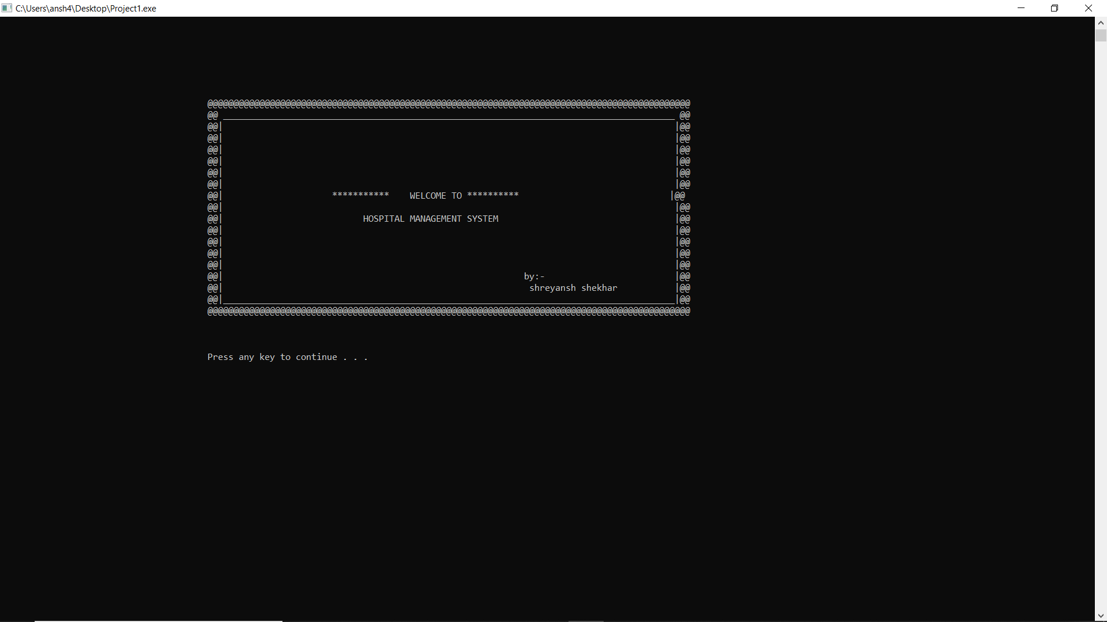

1. After the given the password:- pass

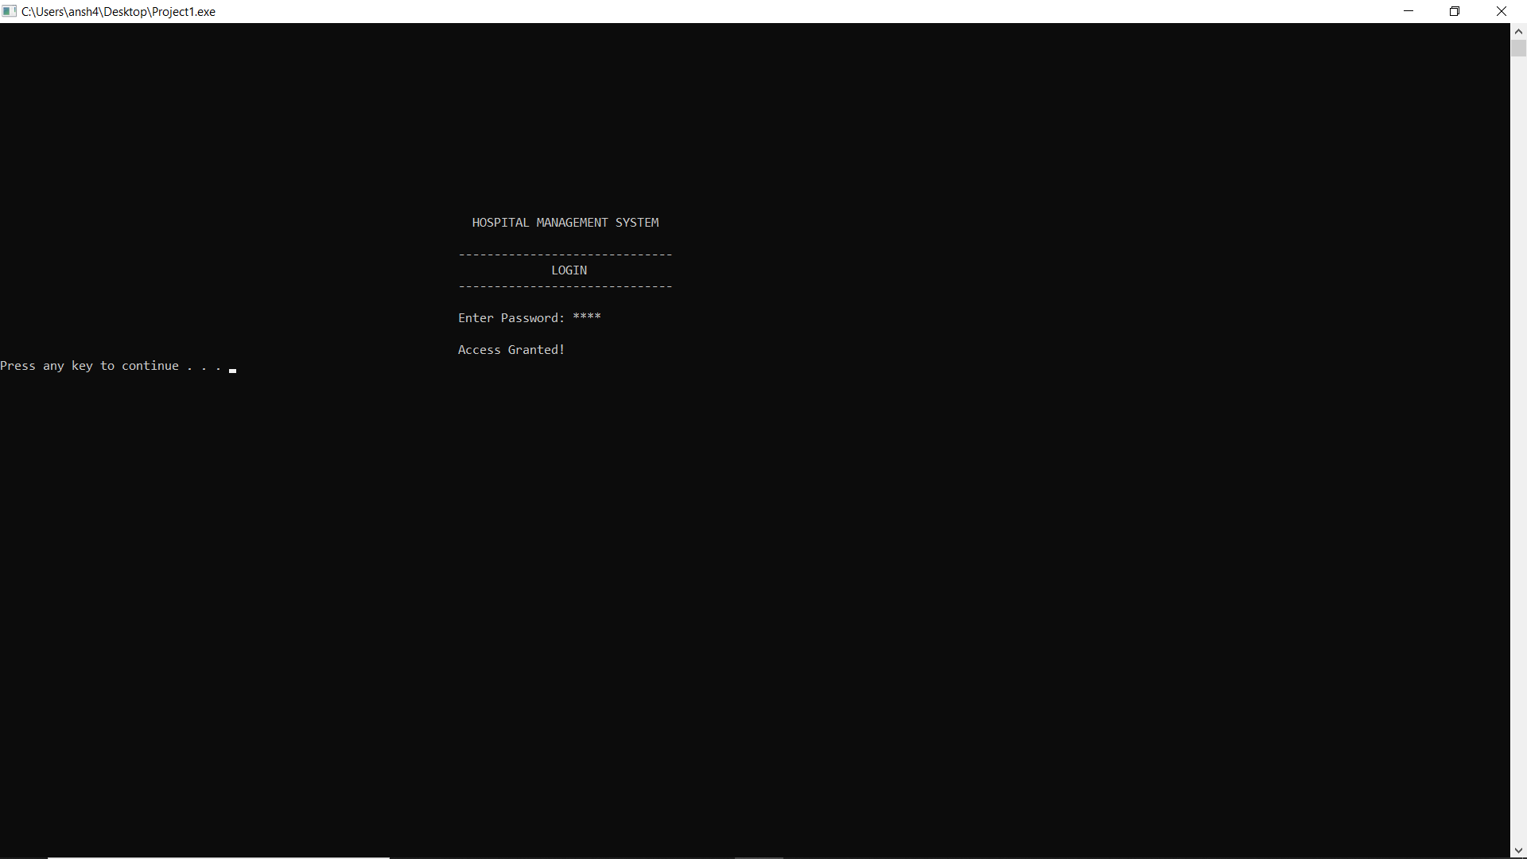

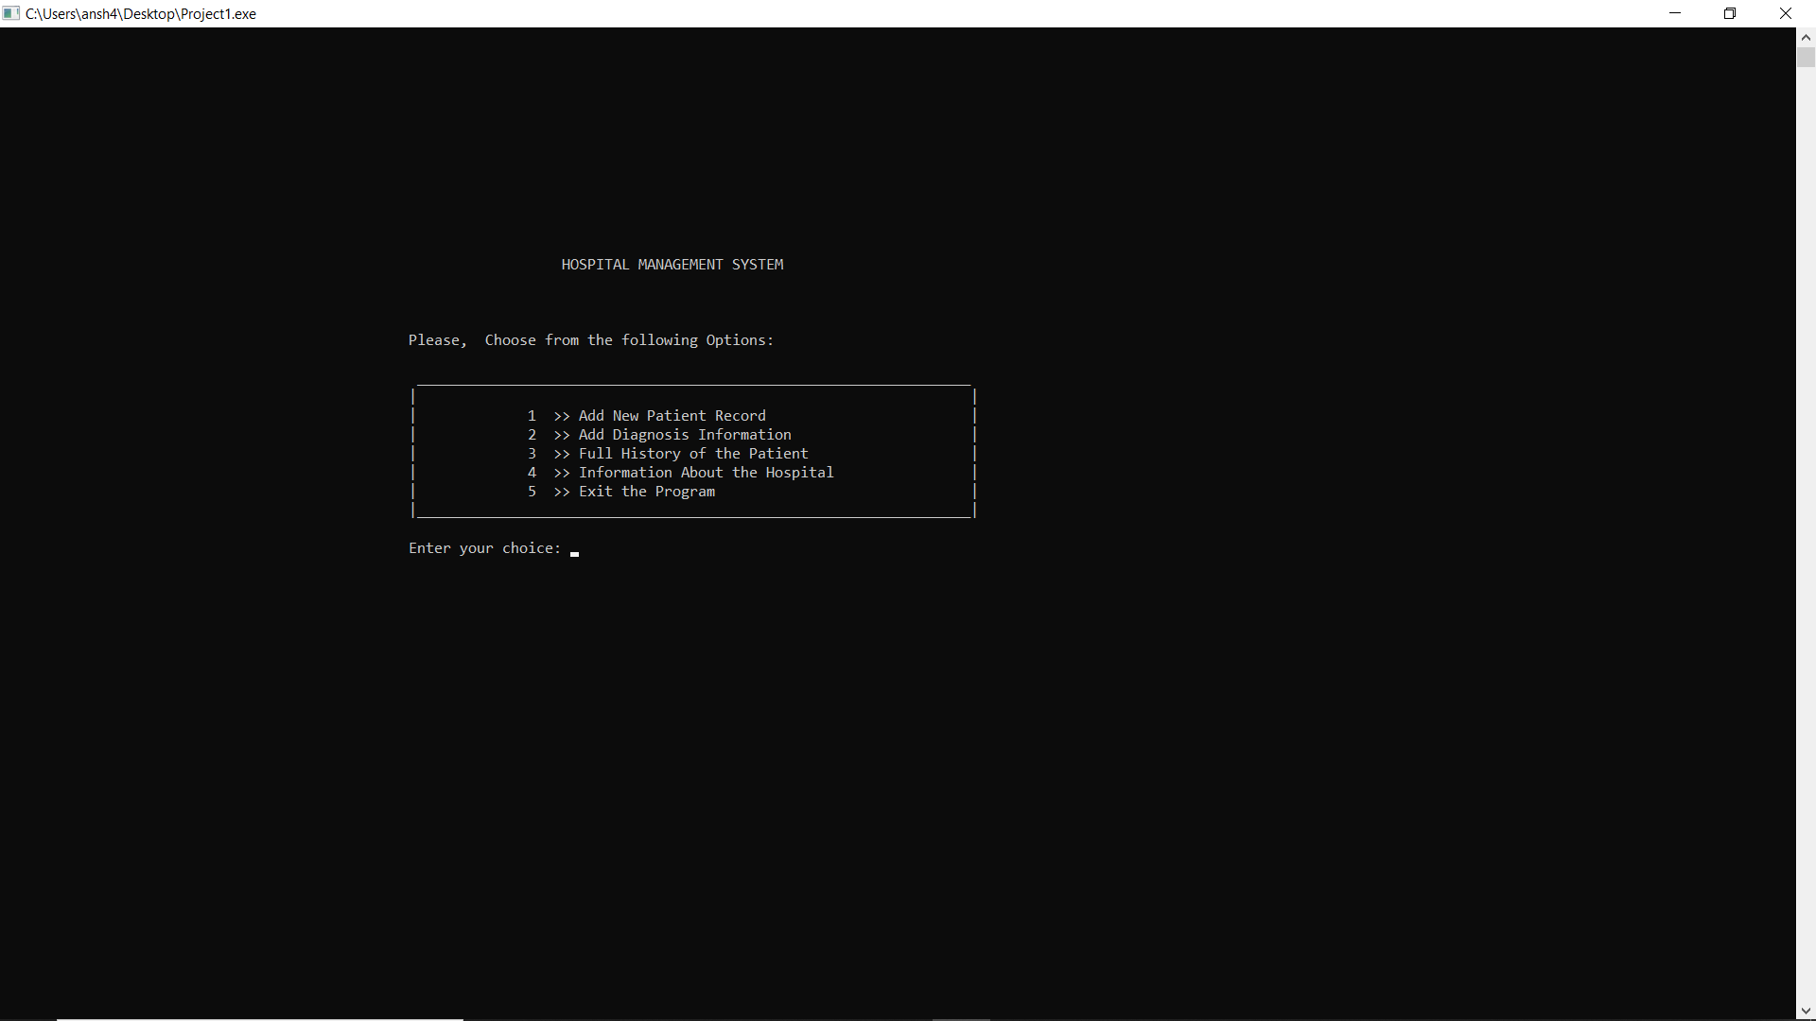

1. After enter the choice 1

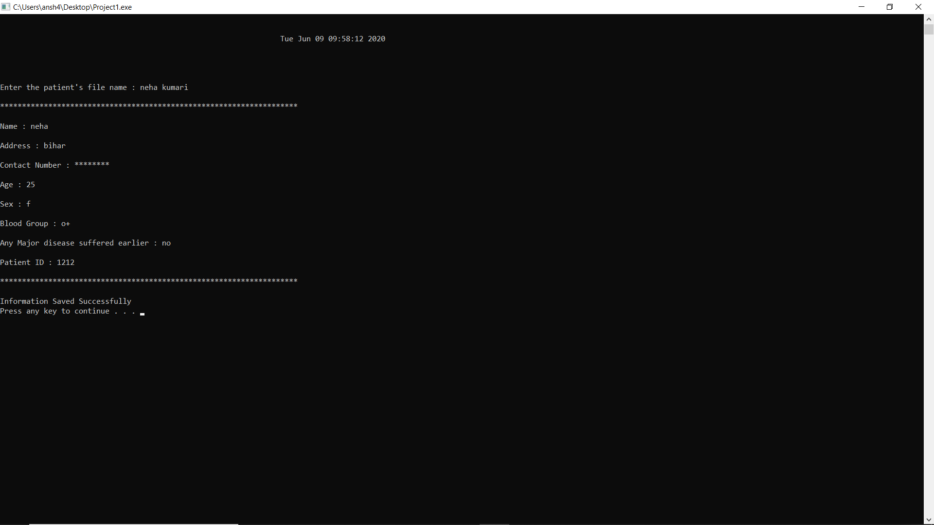

4.After enter choice 2

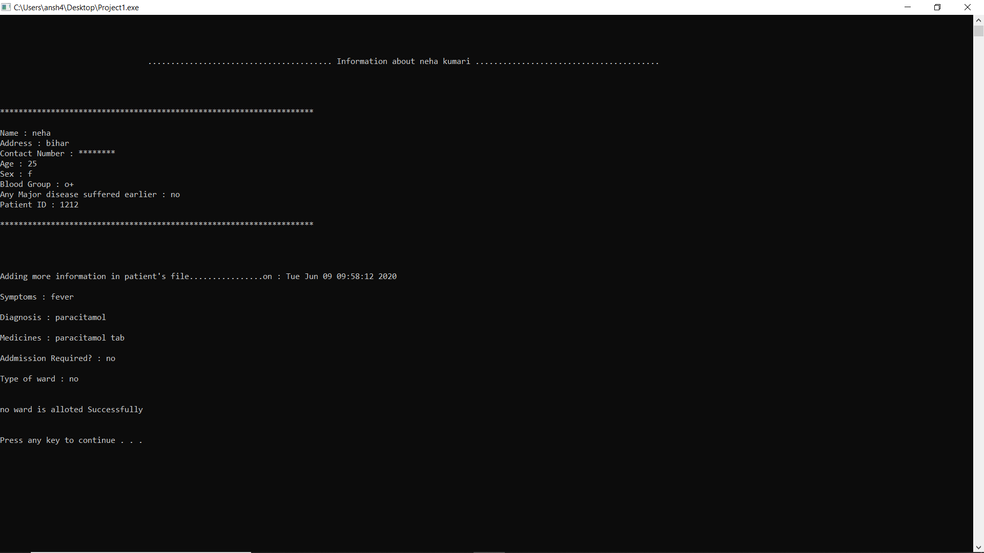

1. Ater enter choice 3 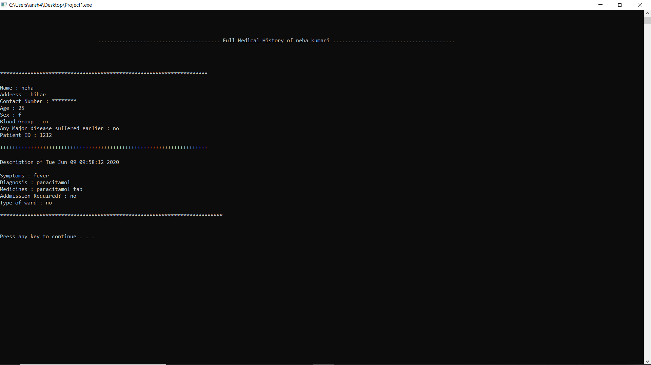

**CONCLUSION**

The project Hospital Management System (HMS) is for computerizing the working in a hospital. It is a great improvement over the manual system. The computerization of the system has speed up the process. In the current system, the front office managing is very slow. The hospital managing system was thoroughly checked and tested with dummy data and thus is found to be very reliable. The software takes care of all the requirements of an average hospital and is capable to provide easy and effective storage of information related to patients that come up to the hospital. It generates test reports and also provides the facility for searching the details of the patient. It also provides billing facility on the basis of patient’s status whether it is an indoor or outdoor patient. The system also provides the facility of backup as per the requirement.

**LIMITATIONS**:

**.** The size of the database increases day-by-day, increasing the load on the database back up and data maintenance activity.

**.** Training for simple computer operations is necessary for the users working on the system.

**WEB** **REFERENCES**

1) An integrated approach to software engineering, Third edition by Pankaj Jalote

2) OOP in C++

3).www.google.com